INTRODUCTION
How we communicate says a lot about who we are. Good communication doesn’t merely come from the words we’re using. The skill of the writer can finesse a canvas with colourful words that bring to life a picture and story – but a good communicator knows who they’re speaking to, and can write for the needs of the reader. Understanding how our audience reads and listens is key to how we write our voice. Our voice doesn’t change, the tone we use depends on who we’re speaking to.
Words have power.
They can drive confidence in people.
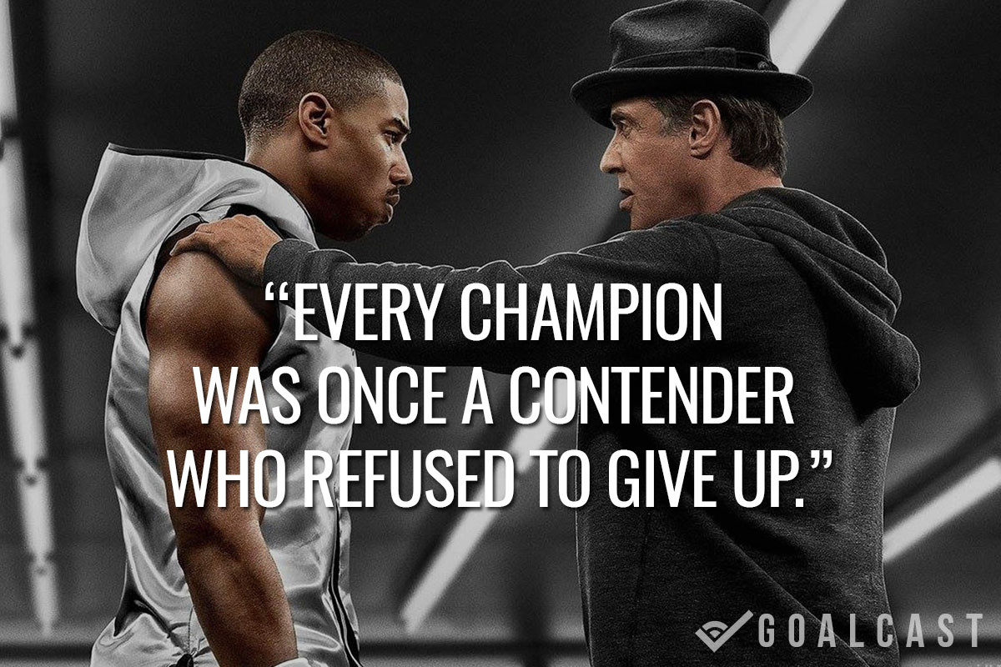
They can present harsh truths,
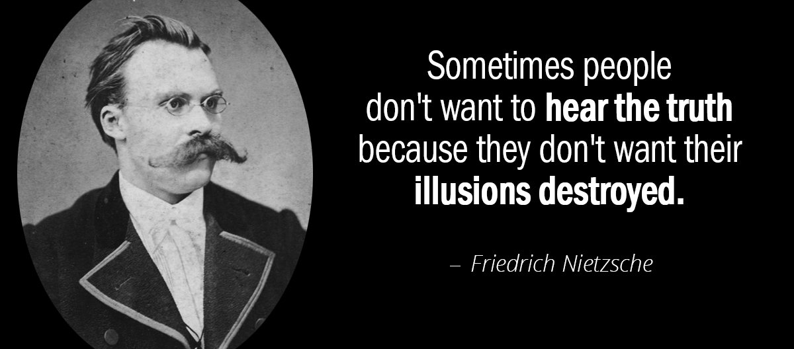

Words can empower action.


They can express character

The words we use are tied into our values and coordinate how we speak to our audience. We want to leave a good impression by leaving the right impression and the right image in the minds of our readers. So, if you’re writing your tone of voice for yourself, or if you’re doing it for a company, be aware: WORDS MATTER!
As a writer of science fiction or fantasy, you’re going to want to be a science fiction and/or fantasy fanatic. You’re going to want to follow the sites and pages, the magazines and fan-fiction reddit stuff. You’re going to be familiar with the concepts, the vocabulary, the nomenclature and neologisms.
And that same goes for your market segment:
If you’re writing copy for gaming, you’re going to want to be submerged in gaming literature and events. If you’re in journalism, you’re going to be collecting all kinds of acronyms for deconstruction and delineation to your reader base.
So, let’s start with some general tips and good to know practices before moving on to developing your voice and your tone:

GENERAL COPY TIPS

- Customer-centric:
- When writing your copy for a firm, use less WE and more YOU language. Sentences like ‘we are, we believe, we will,’ should be substituted where possible as ‘you get, you’ll find, you can…’ This way readers understand that their needs are being heard and understood.
- Show don’t tell:
- If they’re stressed, use language that speaks to the pain point. If they’re confused, talk to that confusion then promise to centre them. People make decisions, not from need, but from want. Use emotive language to tap into how readers feel. Settle offers protected and private transactions, because our customers don’t trust their data to 3rd parties. Show you understand this pain. You can tap into a fear of data leaks to motivate interest, or refer to research: (91% Americans “agree” or “strongly agree” that people have lost control over how personal information is processed – we think things should be different.)
- Be inspirational:
- Use descriptive language that builds an image – detail evokes a genuine feeling in readers.

- Be Helpful:
- Think how you can be helpful to your readers and solve their problem. Talk about the result, not the product: (This app keeps purchase data private and your details secure.)

A LIST OF POWER WORDS
Power words, when picked correctly, can amp up your marketing and speak to people’s emotions. We’re emotional creatures and our decisions are made mostly from an emotional trigger. It’s down to you to justify why your audience need what you’re providing – or value what you’re doing. If you’re trying to seduce your reader, consider vivacious language. If you’re appealing to their fears, provoke a pain point with fear words and appease it with your solution.
Here’s a list of power words that you can use to grab attention:

POWER WORDS FOR FEAR
Agony, Apocalypse, Armageddon, Assault, Backlash, Beating, Beware, Blinded, Blood, Bloodbath, Bloodcurdling, Bloody, Bomb, Buffoon, Bumbling, Cadaver, Catastrophe, Caution, Collapse, Corpse, Crazy, Cripple, Crisis, Danger, Deadly, Death, Destroy, Devastating, Disastrous, Drowning, Dumb, Embarrass, Fail, Feeble, Fired, Fool, Fooled, Frantic, Frightening, Gambling, Gullible, Hack, Hazardous, Hoax, Holocaust, Horrific, Hurricane, Insidious, Invasion, Jail, Jeopardy, Lawsuit, Looming, Lunatic, Lurking, Meltdown, Mired, Mistake, Murder, Nightmare, Painful, Pale, Panic, Peril, Piranha, Pitfall, Plague, Played, Plummet, Plunge, Poison, Pummel, Poor, Prison, Pus, Reckoning, Refugee, Revenge, Risky, Scary, Scream, Searing, Shatter, Shellacking, Silly, Slaughter, Slave, Smash, Strangle, Tailspin, Tank, Targeted, Teetering, Terror, Toxic, Trap, Vaporize, Victim, Volatile, Vulnerable, Warning, Worry, Wounded
POSITIVE POWER WORDS
Amazing, Audacity, Backbone, Belief, Blissful, Bravery, Breathtaking, Cheer, Conquer, Courage, Daring, Defiance, Delight, Devoted, Excited, Eye-opening, Faith, Fearless, Fulfill, Grateful, Grit, Guts, Happy, Heart, Hero, Hope, Jaw-dropping, Jubilant, Magic, Mind-blowing, Miracle, Pluck, Sensational, Spectacular, Spine, Spirit, Staggering, Stunning, Surprising, Triumph, Uplifting, Valor, Victory, Wonderful, Wondrous
LUSTY POWER WORDS WITH SEX APPEAL
Brazen, Crave, Depraved, Dirty, Exposed, Forbidden, Hypnotic, Lascivious, Lick, Lonely, Lust, Naked, Naughty, Provocative, Scandalous, Sensual, Sex, Shameless, Sinful, Sleazy, Sleeping, Spank, Steamy, Sweaty, Tantalizing, Tawdry, Thrilling, Uncensored, Wanton, Whip.
POWER WORDS THAT TRIGGER ANGER
Abuse, Arrogant, Ass-kicking, Backstabbing, Beat-down, Bullshit, Bully, Coward, Crooked, Crush, Disgusting, Evil, Force-fed, Foul, Hate, Know-it-all, Lies, Loathsome, Loser, Lying, Maul, Money-grubbing-Nazi, No-Good, Obnoxious, Payback, Pound, Preposterous, Punish, Revolting, Ruthless, Sick and Tired, Smug, Sniveling, Snob, Snooty, Snotty, Stuck-up, Underhanded
POWER WORDS THAT GREASE THE GREEDY PALM
Bargain, Best, Billion, Bonanza, Cash, Cheap, Discount, Dollar, Double, Explode, Extra, Feast, Fortune, Free, Freebie, Frenzy, Frugal, Gift, Greatest, Inexpensive, Jackpot, Luxurious, Marked-down, Massive, Money, Nest-egg, Pay-zero, Prize, Profit, Quadruple, Reduced, Rich, Savings, Six-figure, Skyrocket, Soaring, Surge, Treasure, Triple, Whopping

POWER WORDS THAT BUILD TRUST AND ENSURE SAFETY
Anonymous, Authentic, Backed, Best-selling, Cancel, Anytime, Certified, Endorsed, Guaranteed, Ironclad, Lifetime, Moneyback, No-Obligation, No Questions Asked, No Risk, No Strings Attached, Official Privacy, Protected, Proven, Recession-proof, Refund, Research, Results, Secure, Tested, Try before You Buy, Verify, Unconditional,
POWER WORDS FOR THE CURIOUS
Backdoor, Banned, Behind the Scenes, Black Market, Blacklisted, Bootleg, Censored, Concealed, Confessions, Confidential, Controversial, Covert, Cover-up, Forbidden, Forgotten, Hidden, Illegal, Insider, Lost, Off-limits, Outlawed, Private, Secrets, Smuggled, Strange, Unauthorized, Withheld.

NEXT…
AN EXAMPLE OF FINDING YOUR VOICE…
List your values. Your values shape your expression. It comes from the core of what you believe as an individual or as a company. Be clear and concise, say exactly what you mean by your values. Let’s look at an example below:

A software company developing a privacy application is speaking about their values. They list three core values that align their grand vision for all their brands and services:
- SECURE = we treat security with the highest of importance, frequently updating, testing and reconfiguring systems in line with protocol
- COMPLIENCY = we respect and adhere to the legal expectations of our regional operations and we’re respected in return for the financial services we provide.

- TRUST = we are focussed on cultivating trust and advocating for our (clients) customers, to support their needs and be available for them at all times.

YOUR TURN
We’re going to develop a voice by first establishing your values, either as a company or if you’re doing this as an author or individual for your process log, just as well
ANSWER THE FOLLOWING AS BEST YOU CAN:
(This doesn’t have to be set in stone, it can be a matter of just getting some ideas down so in the next step you can refine what is important to you.)
- What drives you?
_____________________________________________________________________
_____________________________________________________________________
_____________________________________________________________________
- What interests you?
_____________________________________________________________________
_____________________________________________________________________
_____________________________________________________________________
- What do you want to know about that thing?
_____________________________________________________________________
_____________________________________________________________________
_____________________________________________________________________
- Why does it interest you?
_____________________________________________________________________
_____________________________________________________________________
_____________________________________________________________________
- What questions haven't been asked about it?
_____________________________________________________________________
_____________________________________________________________________
_____________________________________________________________________
- What themes do you wish to explore? What motifs or patterns?
_____________________________________________________________________
_____________________________________________________________________
_____________________________________________________________________

NEXT: See if you’ve got a better idea of what core values keep coming up. Keep it simple, but really get down what you mean.
VALUE | DEFINITION

NOW: Make a short statement, a content mission that your company aligns with (or that you align with as a writer.) What is your purpose? Your goal.
CONTENT MISSION: - “To be the leading, trustworthy software application developer for fast and reliable customer security.”
MISSION CONTENT: ____________________________________________________________________________________________________________________________________________________________________

OUR BRAND PERSONALITY AND TONE:
Once you’re got down your values, we’re going to get into your tone and this is really about personality.
We are defined by our personality, how we communicate with our customers and how we treat and address each other. Good communicators are in touch with their audience. They listen, they share the same interests, they know how to talk to them.
EXAMPLE OF TONE:
Let’s take two or three small examples of tone:
- HONEST = a principled approach, upfront and confident
- INFORMATIVE = useful and professional in delivery
- EMPOWERING (relatable) = empathise with customers, sharing confidence

VALUE | HONEST
What we mean | Principled, well mannered, upfront, confident and assuring.
What we don’t mean | Ambiguous, a lot of grey-area, unexplained items and agenda, confusion, inconsistencies.
How it looks | I can see how clear they are about what I can expect on this journey. I can trust them – they’re honest about what happens to my data and upfront about why problems occur and how they can be amended. I like how confident they are in forming affective solutions and they’re supportive and in touch with me throughout my experience, without being a pest.

VALUE | INFORMATIVE
What we mean | Clear, easy-to-read, comprehensive, relevant, instructive, supportive.
What we don’t mean | Vague, confusing, mismanaged and overlooked, unaware, passive, patronizing
How it looks | I have an easy time with the customer experience and sit navigation. The helpline is easy to find and I’m always reminded there’s someone on-hand to talk me through any issues I have. I’m not intimidated by the verification process, it’s easy and friendly and logical, with explanations and clear language along the way that talks to me as a person, not a robot. It’s human, patient and it isn’t patronising.

VALUE | EMPOWERING
What we mean | Engaging, encouraging, exciting, friendly.
What we don’t mean | Dull, unsympathetic, remote, insincere and over-familiar.
How it looks | I feel they’ve got my back, they’re not in my face and constantly spamming me, but they’re checking in occasionally to see if I’m alright with relevant content that’s aligned with their services. They seem excited for my success and they supply tips and vital information to help me on the way and make the process as easy as possible. I’m never concerned that something will go wrong because they’re giving me all I need to feel secure.

NB: In terms of a company tone of voice, it’s worth remembering that these personality quirks would have to be contextualised for all departments. As a copywriter, you’d have to vet the process, look at which departments are talking to customers and partners and ensure they’re versed on the scripted style. In this way, when they’re speaking, the voice is consistent.
YOUR TURN
Define the values for yourself, play with ideas and have fun.
If you’re a copywriter for a company, these will be a little easier to clarify and would be worth doing so in group conferences. Optionally, you could distribute these as a questionnaire to get deeper insights on your company culture.
VALUE
What we mean
What we don’t mean
How it looks

VALUE
What we mean
What we don’t mean
How it looks

VALUE
What we mean
What we don’t mean
How it looks

THIS NOT THAT
It’s important to get to grips with what we’re saying and what we mean by the words we’re using. But it’s equally important to state what we don’t mean.
Take a look at these examples. This was written for a Fintech application. See how the writer justifies the tone, why this and why not that.
“We’re clear,  -NOT ambiguous.” | We write simply. The format is elegant and we don’t throw around jargon. We may talk about our segment’s technicalities. For instance, if we’re an online e-payment platform we might use (CNP, AML, KYC, PEP, EDD and fraud as well as some legal terminology) but in many cases, customers and clients are familiar with these terms. But we mustn’t leave room for ambiguity.
“We’re semi-formal,  -NOT ceremonial.” | Our tone is semi-formal. We don’t engage in slang to force an appearance and we’re light, but not too jocular. People don’t want their money being treated frivolously. Customers want to know that we’re an authority they can trust and that we’re carrying out their investments to the letter. Keep it human, be real, and steer wide of the dull, sterile writing. We want to be partners and we want to be connectors - leave your readers feeling safe.
“We’re expert,  -NOT arrogant.” | Our customers are looking for the payment technology expert in the room. We have a proud background in financial solutions, which means we have to be on their radar, with nothing to prove. When we talk about Settle, we come from the values we hold and our commitment to our services, no bragging. We’re excited to put people onto this solution, to be ahead of the curve, to understand our customer’s situation and empathise with it.
“We’re professional,  -NOT bombastic.” | To be a proud advocate of our financial company is to champion its cause – but there’s a fine line to tread between being professional and being self-inflated. We want results to speak for themselves. Our customers go through a journey, and we must be their guardians as they move. Our copy reflects the path they’re on, and we are conscious of overcoming challenges as they grow. We too have come from a place that has grown from challenge and tribulation, and our professionalism here will help guide them and move them seamlessly through the customer journey.
“We’re persuasive,  -NOT annoying.” | This isn’t about us – it’s about what our services can do for our clients and customers, how innovation can ease their problems. Reciprocity is important for familiarity, our emails address individuals by name, our services offer free insights, we develop surveys to understand our customer’s needs. Our product is made specifically for their needs, a rare gift that’s free to download, doesn’t sell data or track customers. Our copy is written to persuade – but we have to be cautious of badgering. Yes surveys, but not strong obligations – yes choice, but not too much choice – yes questions, but setting up yes/yes answers instead of no/no answers (would you prefer this or that? > becomes would you prefer this or this?). We need to set-up the problem clearly, and use the window of decision wisely.

OVER TO YOU…
Try a THIS not THAT exercise that renders down your personality. Be colourful if you can be. Remember, not all segments are as lively as Netflix. If you’re selling car parts and washing machine pieces, chances are you’re going to want to sell specific features clearly while driving an emotional appeal. This is a difficult balance to strike, which is why exercises like this are good for giving you some insights and ideas how to approach it.
“I’m (we’re)___________________

But not_______________________”

“I’m (we’re)___________________

But not_______________________”

“I’m (we’re)___________________

But not_______________________”

Some Rules to Remember When Writing:
STYLIZATION & PRAGMATICS
- Intention & Audience:
- Before starting any written form, ask yourself the two following questions: 1) What am I saying? 2) Who am I saying it to? Quality content provides a target audience with value (answers questions, provokes pain points, provides research and important news or presents a controversial statement.
- Notes before form:
- Don’t work backwards. Collect as much information on your topic as you can, make notes before putting your structure together. Focus on one main point and if it’s web content, let the vocabulary complement and play on your point. (This can sometimes be done with metaphors – they strike imagery, tell a story and seed ideas.)
- Simple language:
- Yes, it’s tempting to evince one’s multifaceted and unassailable grasp of prose. Avoid this. If there is an easy way to say something, take the easy way.
- Comprehension:
- Do your readers understand the message? If it is a call to action – is it clear where they must go and what they must do? Ask yourself twice, read it thrice. Check with your colleagues.
- Paragraph Breaks:
- Give your readers room to breathe. Too much text will overwhelm a reader and make them scroll on. Break things us, make reading digestible. (Try to keep long form below 130 words per-paragraph.)
- Use headings:
- Don’t forget to but headlines and sub-headings that build on a narrative for sections in web content. Busy readers will skip to the headlines and usually gloss over the introduction to source their main information.
- Render it down:
- If your sentences are long, get them as short as possible. Usually, much of the writing craft has more than necessary. Keep your SEO tight for web content and be strict to your word count. Most readers have little tolerance for long form. If it goes without saying – don’t say it. Trim. The. Fat.

- Proof in the Edit:
- As important as the writing, editing is a way of reviewing, changing, seeing what we want to keep when the jig-saw pieces begin to assemble. Sometimes, you have to be tough, but don’t trim so much that you lose the identity in your style. Cut the characters, not the personality.

WEB CONTENT GUIDE

- Remember Readability: Users read web content differently and tend to skim content rather than reading in the traditional way. Readers scan for bits of information, so be sure to layout information clearly, in smaller units and clearly headlined with relevant titles.
- Start with the conclusion: Also known as the Inverted Pyramid Style, leading with the conclusion lets readers know what they’re in for. Title the key points that lead to the conclusion thereafter.
- Language: You want to keep your sentences short and tabloid – around 25-30 words a line. Headlines between 4 and 6 words.
- Clarity: Keep your content clear, bold and italics should be used sparingly and consistently when utilised.
- Spelling: Check and double check spelling, be consistent about form – establish before your content is down if you’re using traditional English or Webster’s English.
- Always Deliver: Your writing should always deliver on the promise of the title. Don’t be spammy and don’t use click-bait. Be professional in directing your content to your audience to create authentic traffic.
- Searchability: Be consistent. Google’s Spider crawler won’t rate web content that isn’t focussed. You’ll want to keep your keywords glowing hot in your copy, without repeating phrases or overusing them.
- Keyword Research: Use web tools to narrow down and keep your related keywords and keep your itinerary updated.

